# **SockOps Site Plan**

## **Ellen Tenney**

## **WDD 130**

## **Overview**

### **Purpose**

SockOps is a small, practical platform to stop single-sock loss. We offer a searchable register for lost-and-found socks where users can see the latest locations of found socks using a hover function to see pinned sightings of them on a state level map. Our service coordinates trained community response teams--including formally organized “deploy a mom” search-and-recovery squads--and links to step-by-step repair. We prioritize measurable, repair-first solutions and each listing includes tried-and-true tips for locating the missing half of your pair.

### **Audience**

This site is for any person who experiences the chronic issue of losing one sock out of a pair in their laundry.

## **Branding**

### **Website Logo**

### 

## **Style Guide**

### **Color Palette**

| **Primary** | **Secondary** | **Accent 1** | **Accent 2** |
| --- | --- | --- | --- |
| #0A2342 | #848FA5 | #6A041D | #E0EFDE |

### **Typography**

#### **Heading Font:** Black Ops One

#### **Paragraph Font: Farsan**

### 

### 

### **Navigation**

Home Map More

**Content**

**HOME PAGE CONTENT**

**H1 - Our “Why”**

**P -** SockOps is a small, practical platform to stop single-sock loss. We offer a searchable register for lost-and-found socks where users can see the latest locations of found socks using a hover function to see pinned sightings of them on a state level map. Our service coordinates trained community response teams--including formally organized “deploy a mom” search-and-recovery squads--and links to step-by-step repair. We prioritize measurable, repair-first solutions and each listing includes tried-and-true tips for locating the missing half of your pair.



**H2 - Features**

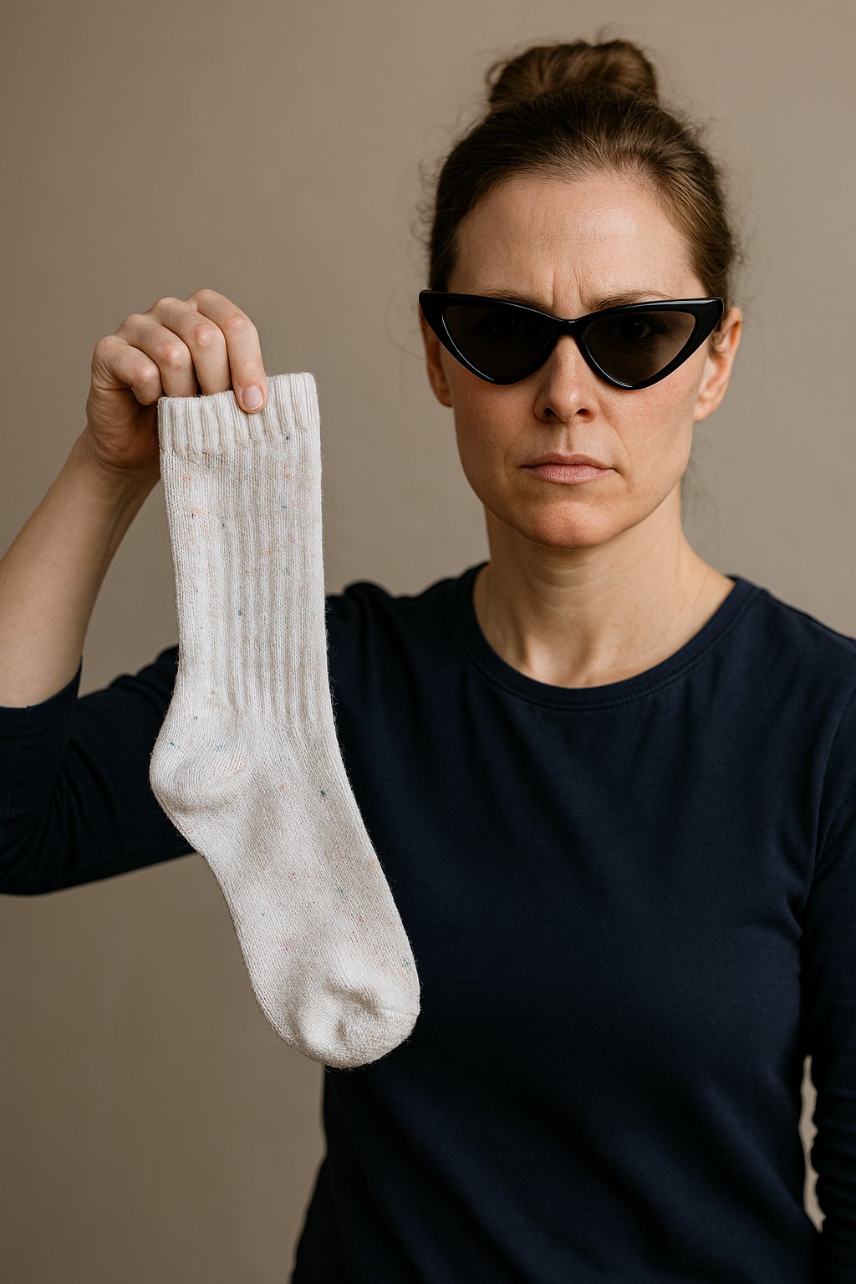**P - Deploy a Mom**

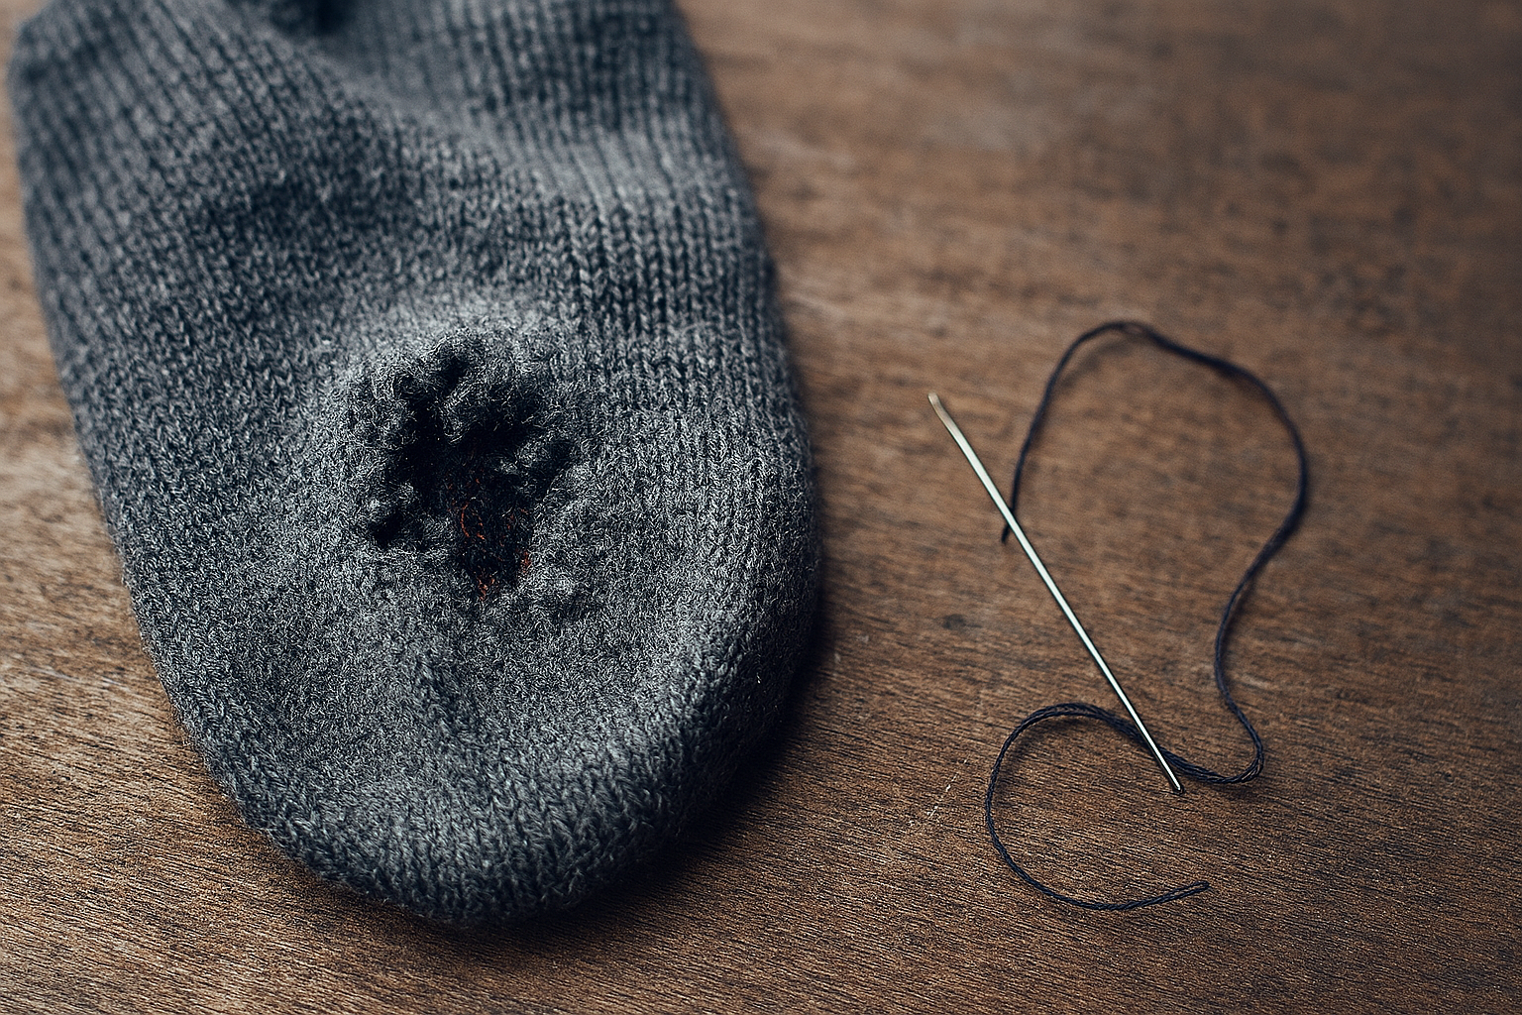**P - Mending Tips**

**P - Lost and found socks**

**(for the footer 3 sections) - ellentenney10@gmail.com**

**made with thread and needles**

**contact us ->**



**MAP CONTENT**

**(have 3 for the map)**

**P1 -** “This sock isn’t mine—my dog brought it in from who-knows-where. It’s white, ribbed, and slightly worn. Logged it on SockOps under Idaho sightings. If it’s yours, it’s safe and dry.”

**P2 -** “Found a single black sock on the corner of Center and Viking Drive, just off campus. No visible markings, slightly faded heel. It might belong to someone heading to class or coming from the gym.”

**P3 -** “I just found a little christmas sock under the sewing table today—no name on it, but it looks freshly washed. If you’re missing one, I’ve got it tucked in my kit for now. Hope it finds its way home!”

**(next 3 images go with the paragraphs)**

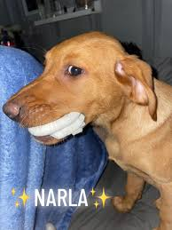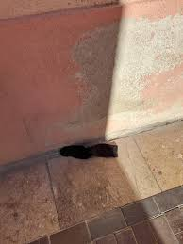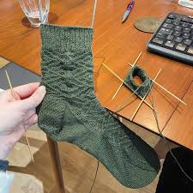

**H1 -** Deploy a Mom



**P1 -** Contact Info:

SockOps HQ: 1-800-FIND-SOCK

sockops@momintel.org

Deployment Zone: Idaho

**P2 -** Meet Sandra Meet Sandra, our top deployed mom. With over 1,400 successful sock recoveries in the past year, she’s earned a reputation for precision, persistence, and results. From college dorms to busy households, Sandra’s the go-to expert when socks vanish without a trace.

**MORE (CHILD 2) PAGE CONTENT**

**Header 1 -** Additional Resources

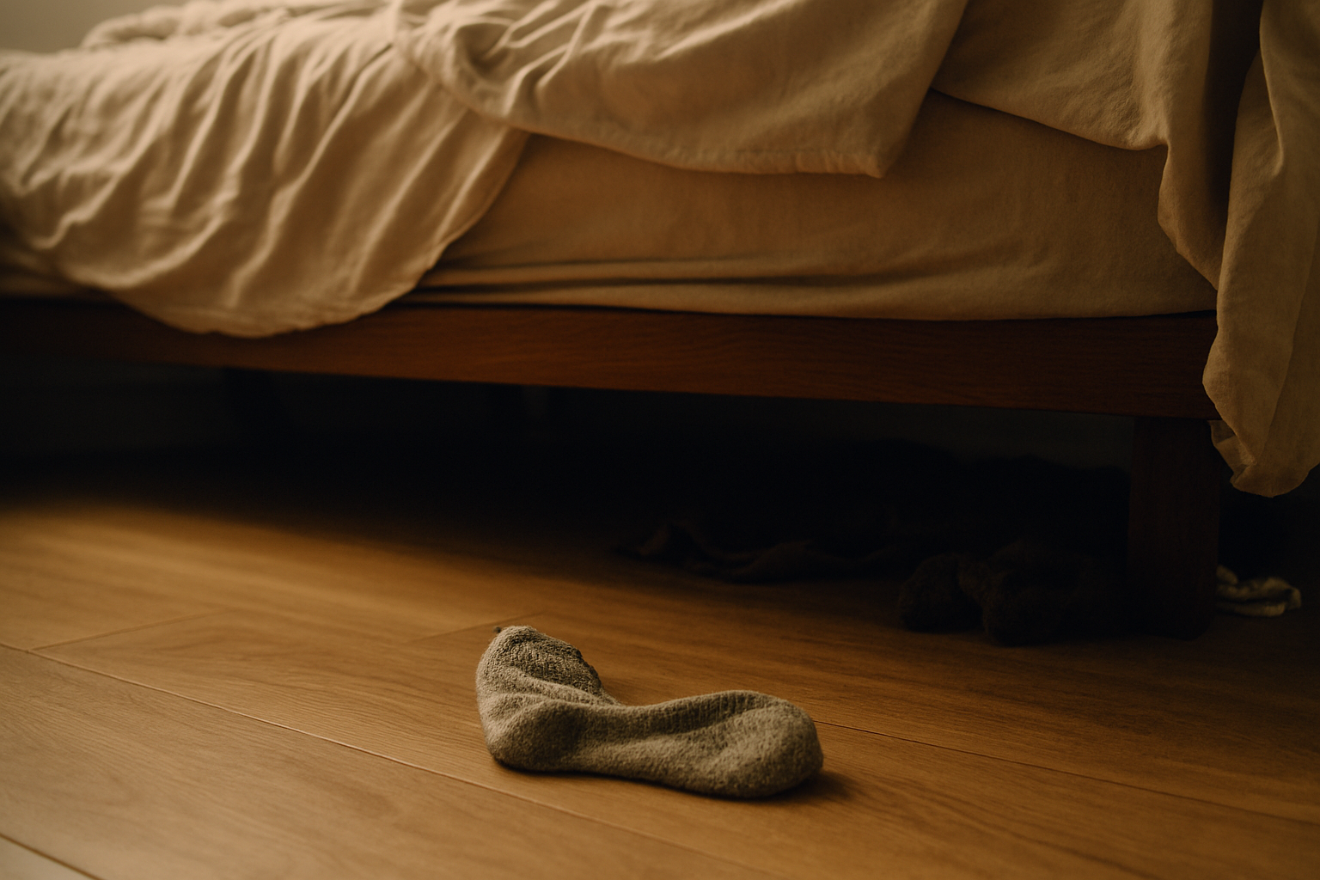

**H -** Sock Recovery Tips

**List -**

* Check the ceiling fan. Just in case.
* Ask your dog. He knows. He just won’t tell.
* Check the dryer. It’s holding them hostage.
* Look in the fridge. You’ve done weirder things.
* Have you asked your mom yet?

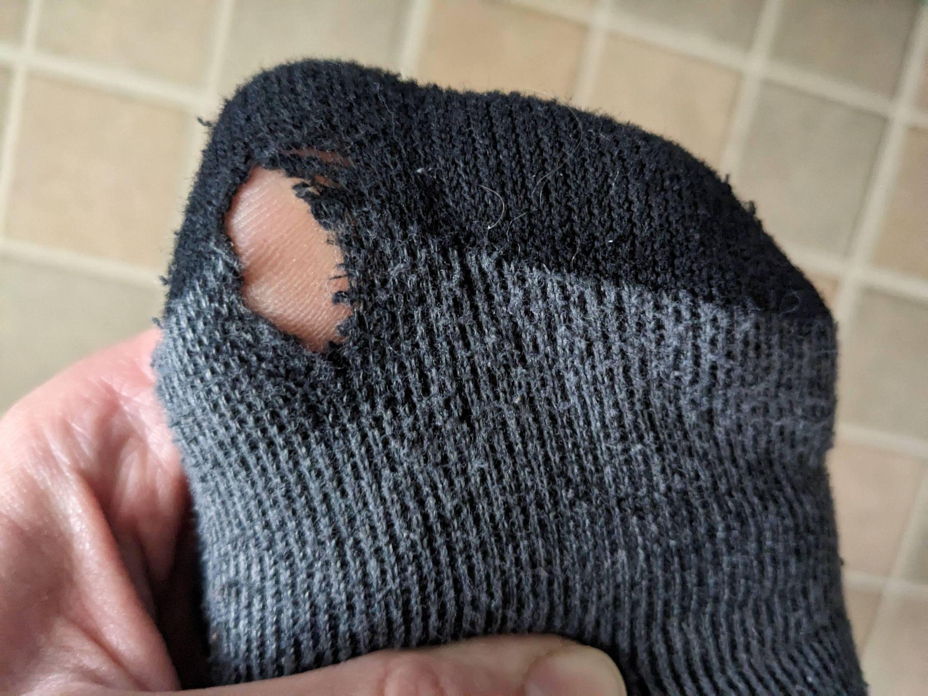

**H -** Sock Mending Sites

**List -**

* https://www.youtube.com/watch?v=NDkMShaLX9c
* https://www.youtube.com/watch?v=ugkiqyRxmpQ
* https://www.youtube.com/watch?v=sBLxhcCuRAw
* https://www.youtube.com/watch?v=dEb6Mnl7i3U
* https://www.youtube.com/watch?v=dQw4w9WgXcQ

**H - Reviews**

(profile pictures)

**P1 -** Jess, 28, Professional Sock Loser *"I used to think socks just vanished into thin air. Then I realized they were staging a rebellion under my couch. Thanks to SockOps, I finally reunited with three pairs — though one still insists on living in the laundry basket rent‑free. Honestly, I respect its independence."*

**P2 -** Raj, 34, Tech Guy *"I once built an app to track my socks using GPS tags. It crashed immediately, probably because socks operate on a higher dimension. SockOps doesn’t just help me find them — it gives me closure. Last week I discovered one inside my laptop bag. I don’t even own a laptop bag."*

**P3 -** Grandma Dot, 76, Sock Philosopher *"A hole in a sock is not a flaw. It’s a window to the soul. But when your socks keep disappearing, that’s just rude. SockOps taught me to check the dryer lint trap, and lo and behold, I found half a sock. Half! I stitched it back together and now it’s my favorite slipper."*

**H -** Contributors:

**List -**

* Polly Ester - Community Manager
* Sockrates - Durability Engineer
* Lacey Cottonsworth - UX Seamstress
* Knitasha Loopman - Style Director
* Wooliam Fuzzworth - Content Weaver
* Darnell Threadson - Head of Repairs

**Wireframes**

### **HOME**

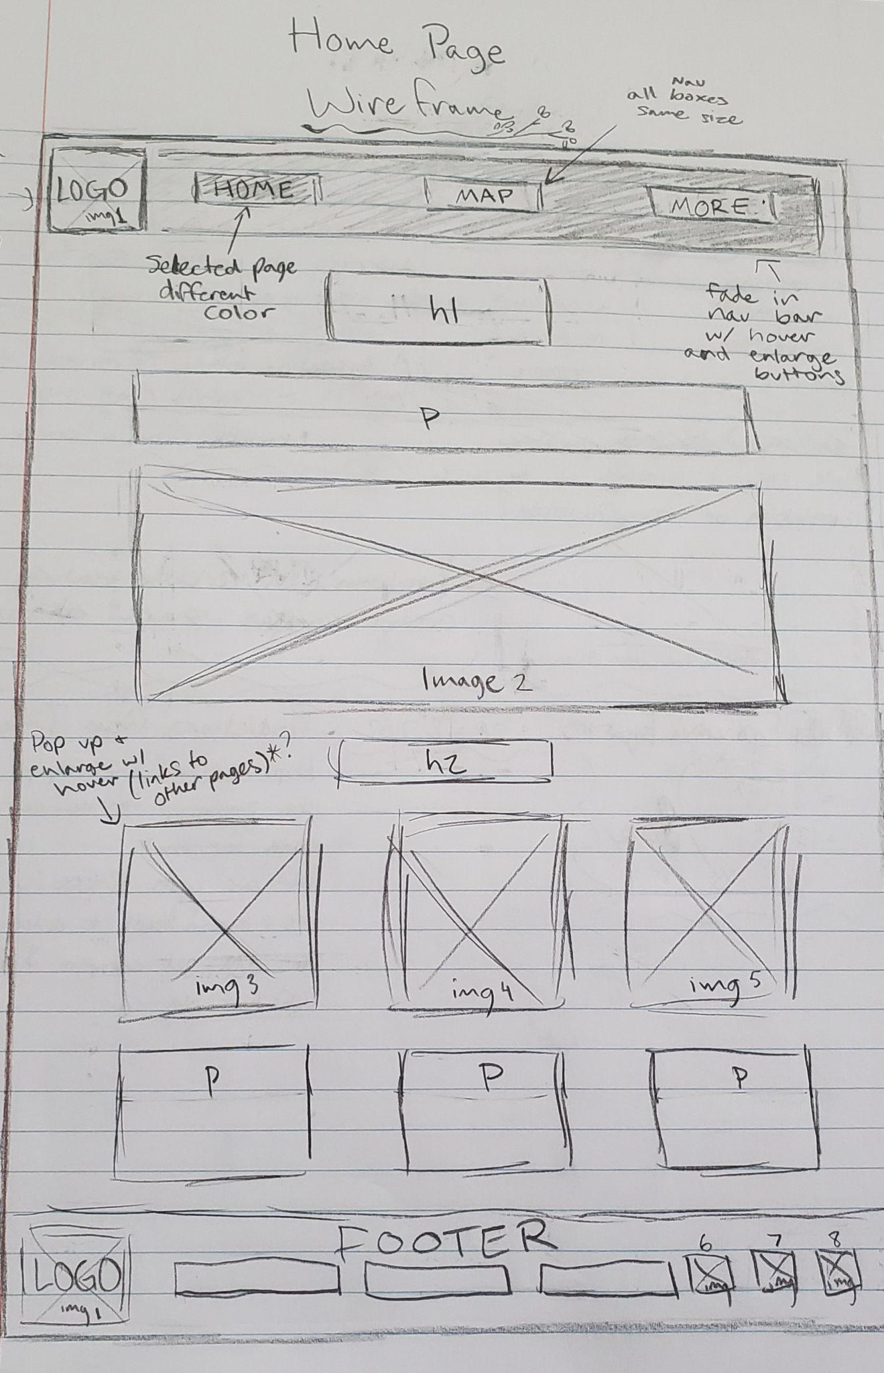

White background. Dark boxes with lighter text, dark borders, shadows on the boxes.

**MAP**

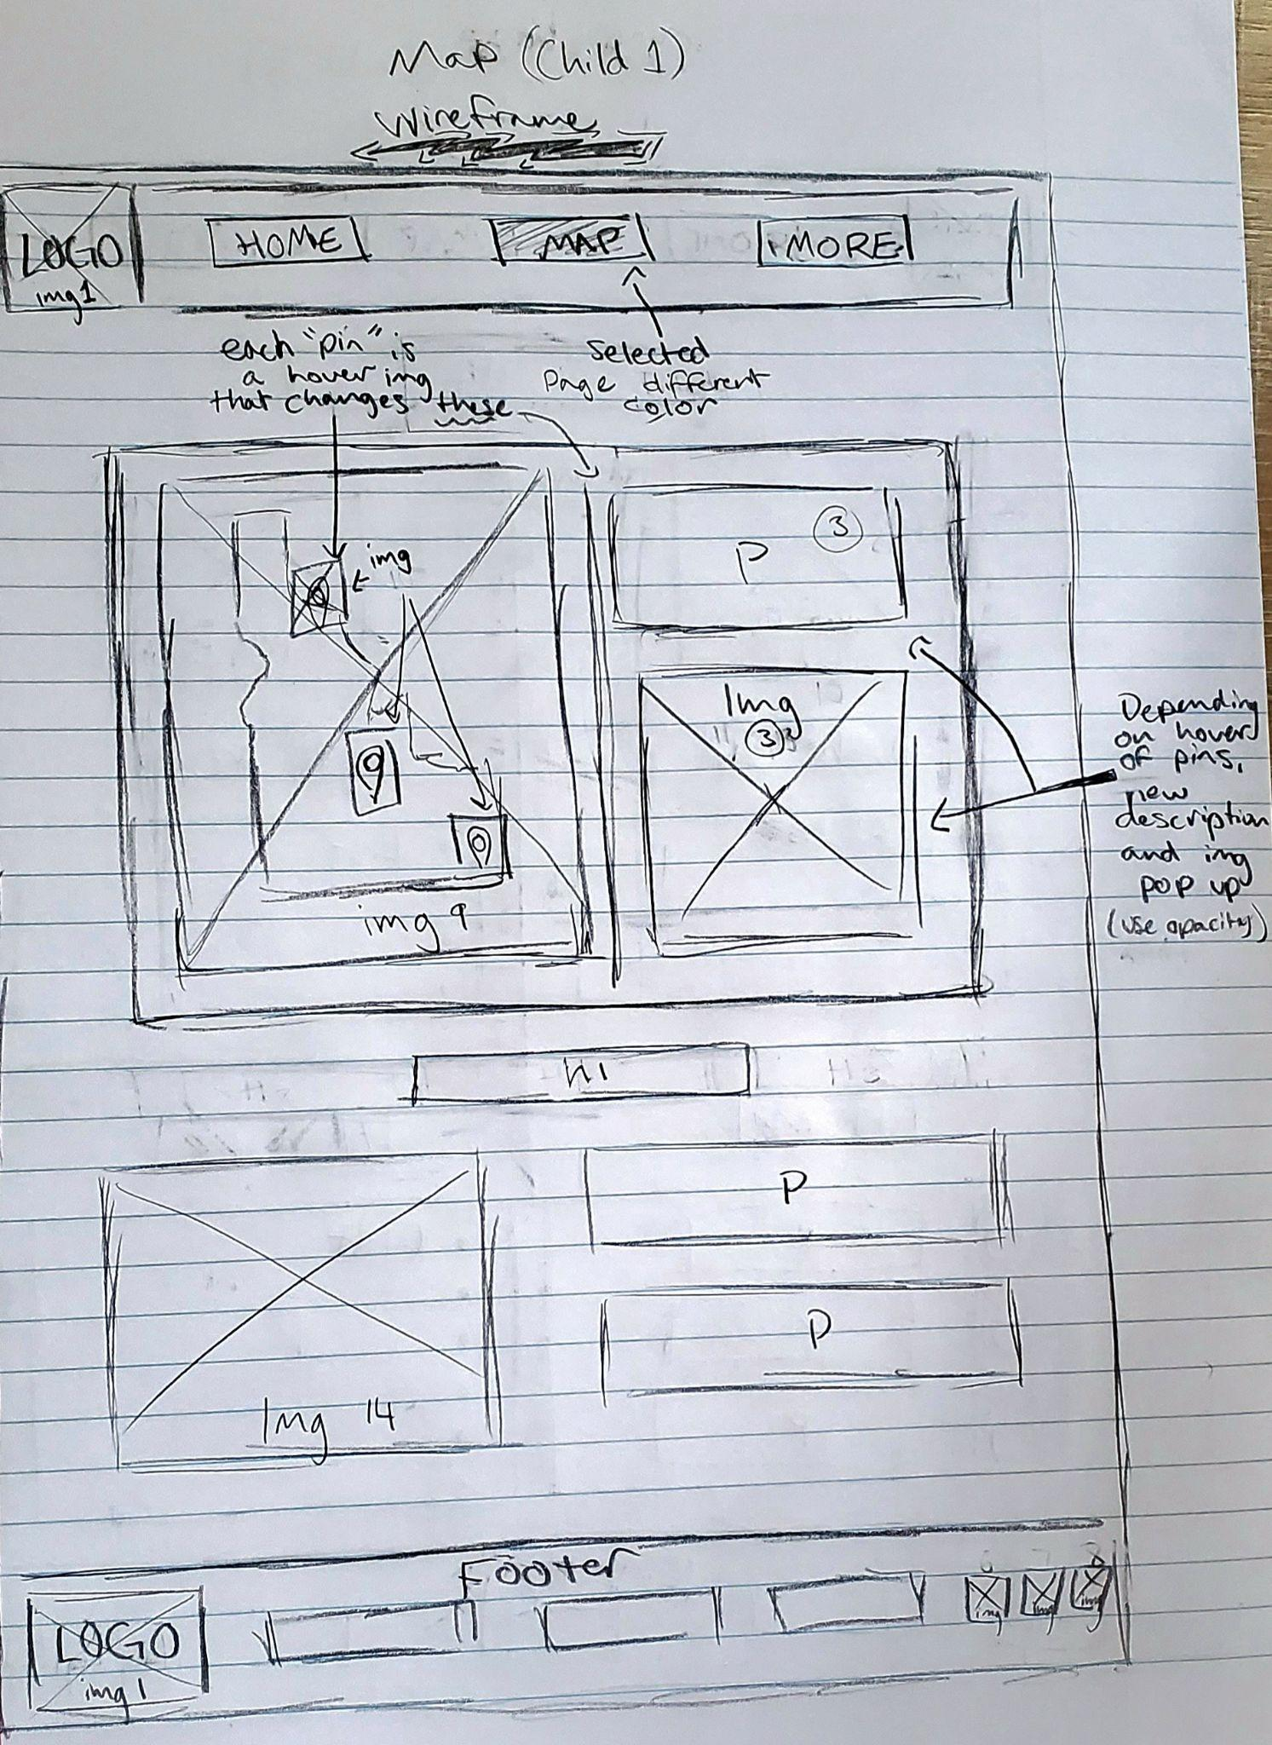

**MORE**

